**Kamji Central School**

**Chhukha Dzongkhag**

**Guidelines to access result of Class PP – VIII for the academic year 2020**

**Kindly follow the steps:**

For Desktop/Laptop users:

1. Open any internet browser (Google chrome/Mozilla Firefox/Internet Explorer etc.)

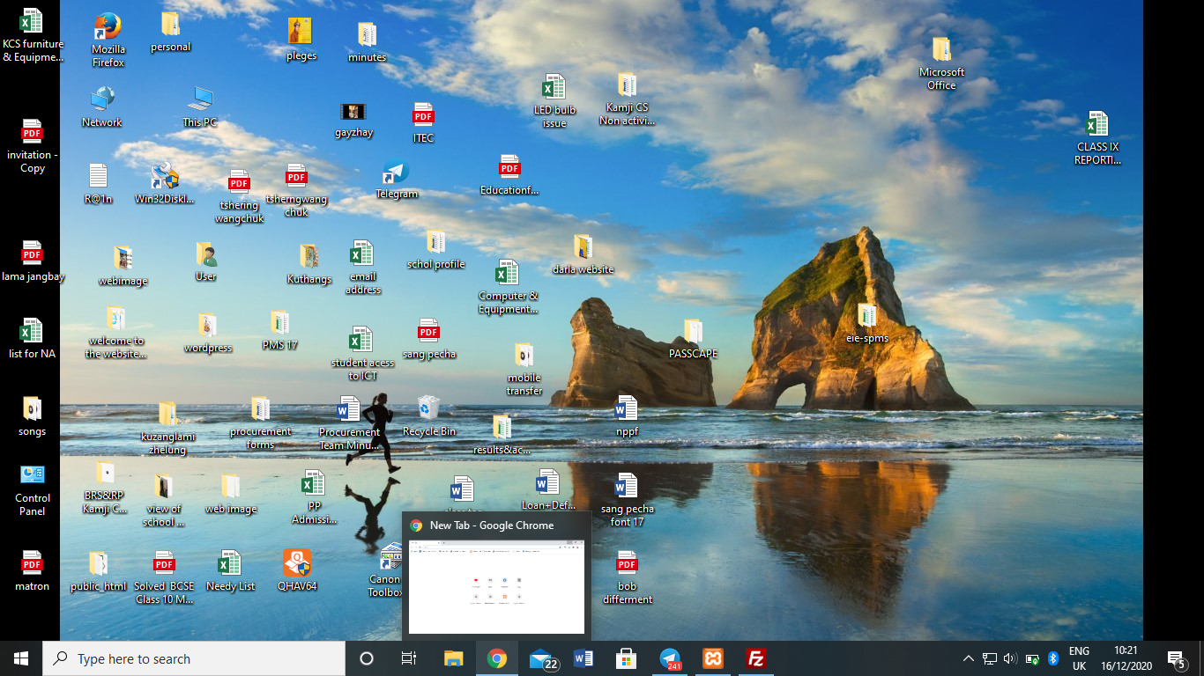

1. Type [www.kamjics.edu.bt](http://www.kamjics.edu.bt) in the URL

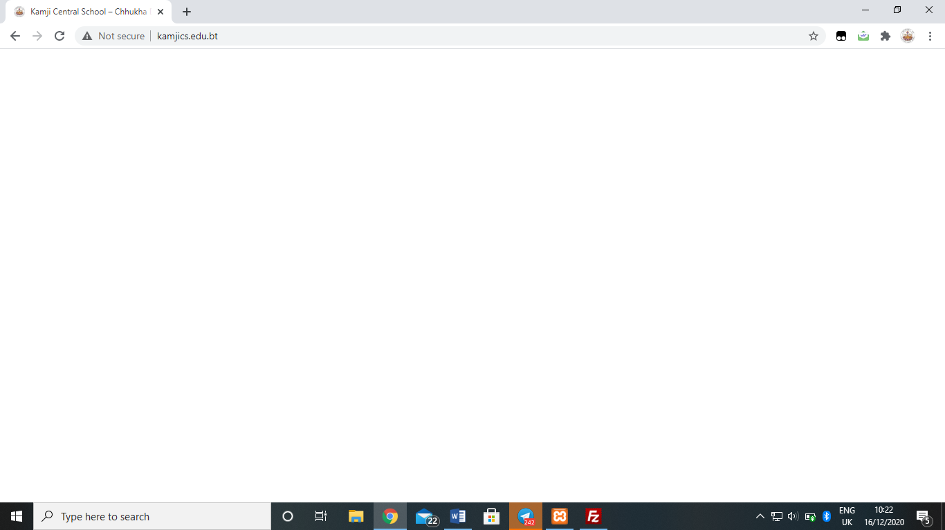

1. 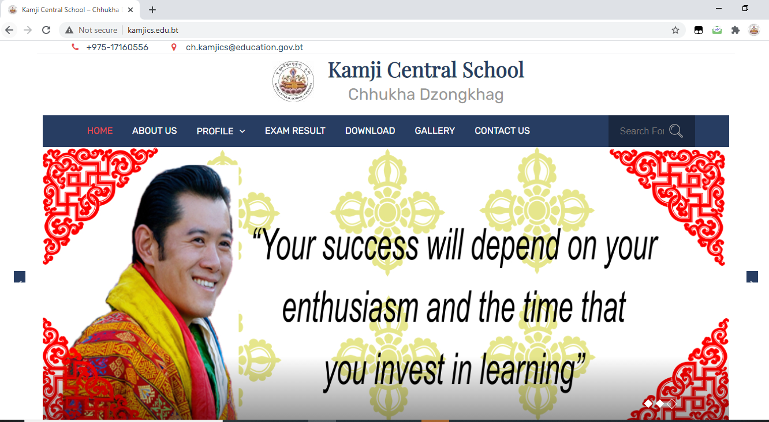The page will appear as follow
2. Click “**EXAM RESULT**” in the menu bar

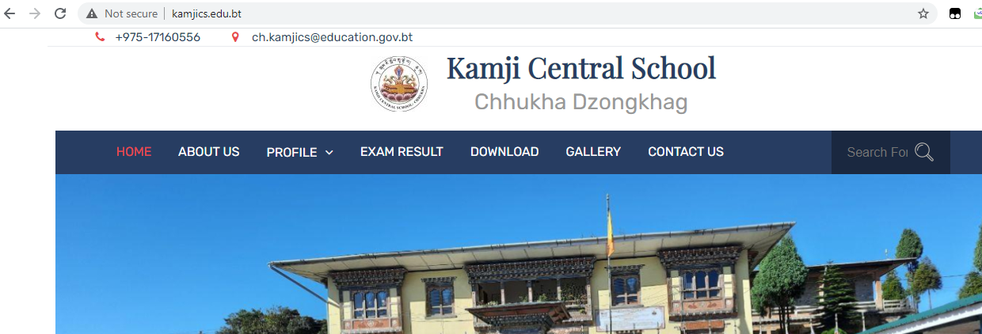

1. The page will appear to enter your correct **STUDENT CODE**

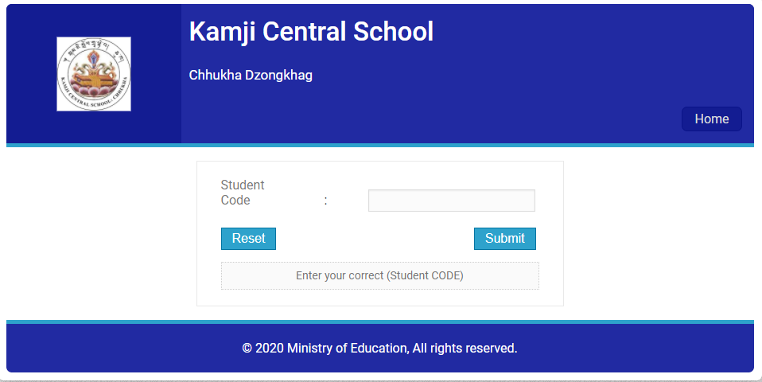Enter your code and hit the “**Submit**” button

1. 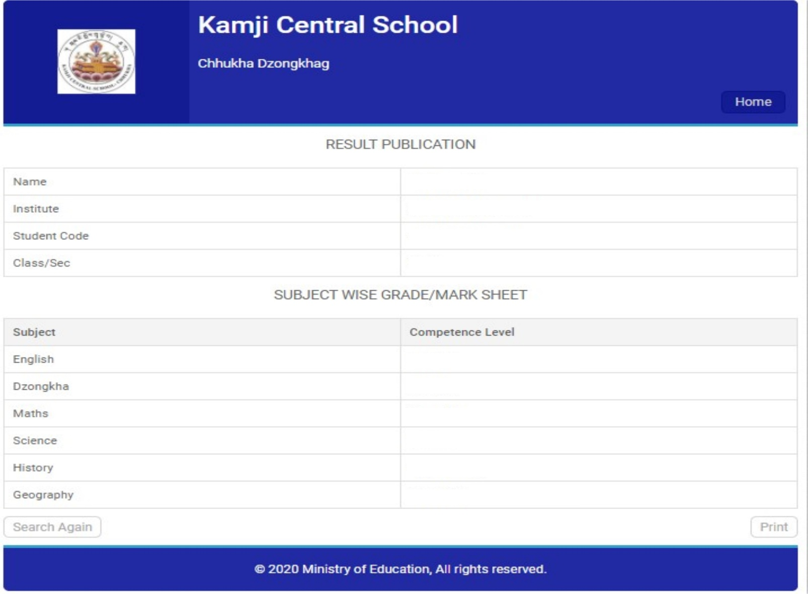Your result page will display as follow:

If you want to print your result, hit the Print button