**Kamji Central School**

**Chhukha Dzongkhag**

**Guidelines to access result of Class PP – VIII for the academic year 2020**

**Kindly follow the steps:**

For smartphone users:

1. Open internet browser (Google chrome)

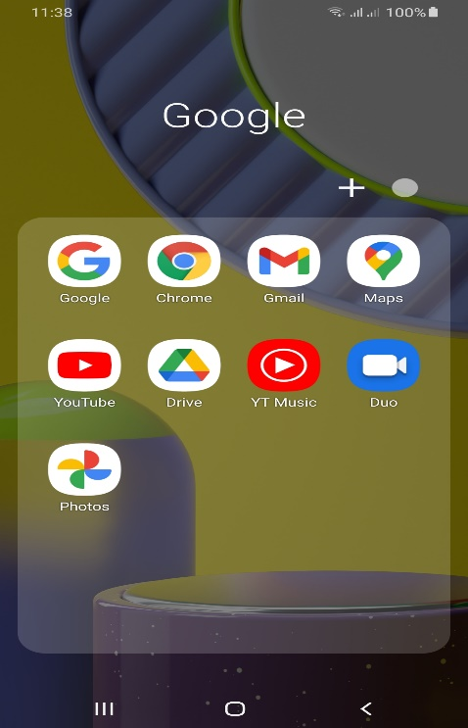

1. Type [www.kamjics.edu.bt](http://www.kamjics.edu.bt) in the URL

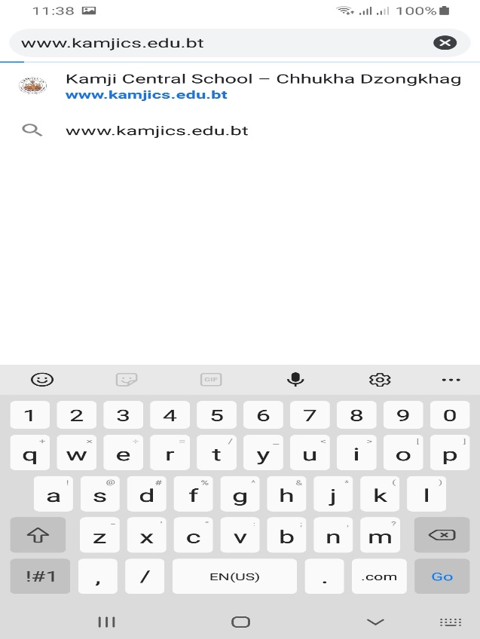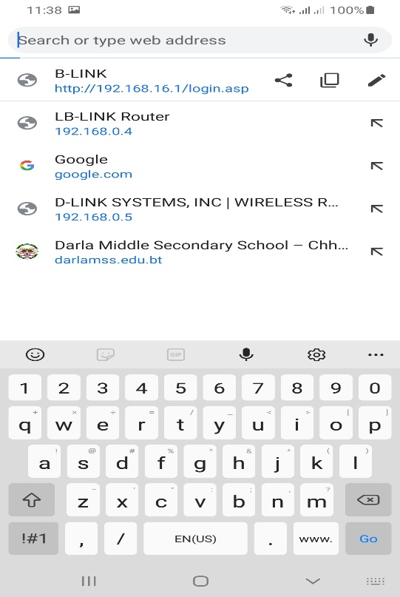

1. The page will appear as follow and click here

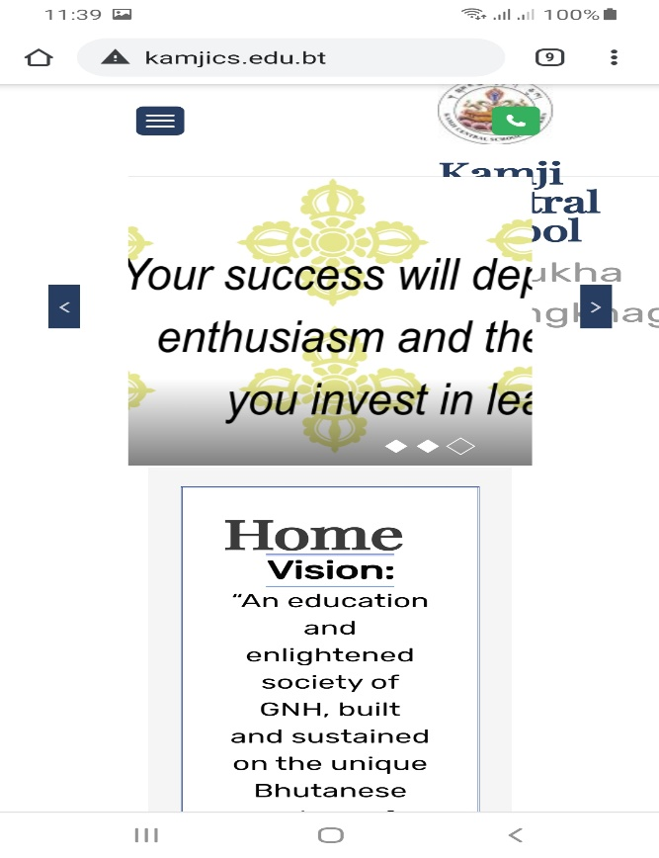

1. 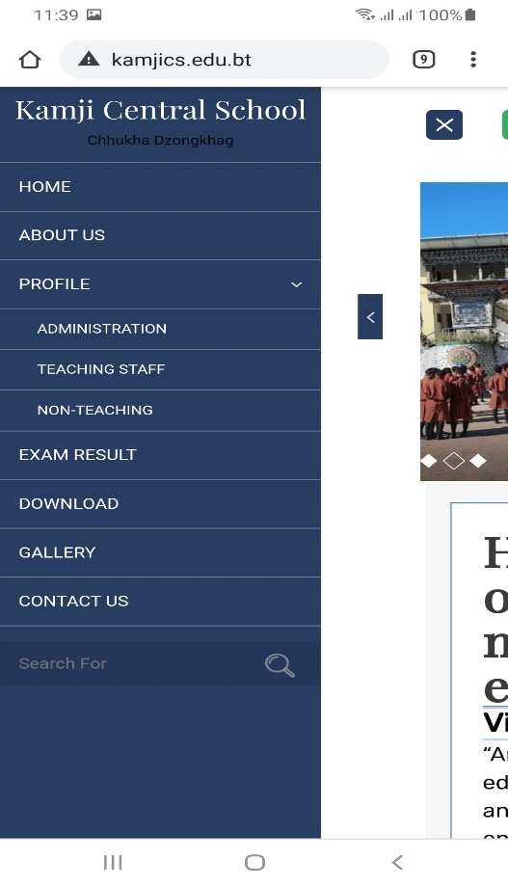Click “**EXAM RESULT**” in the menu bar

1. The page will appear to enter your correct **STUDENT CODE**

Enter your code and hit the “**Submit**” button

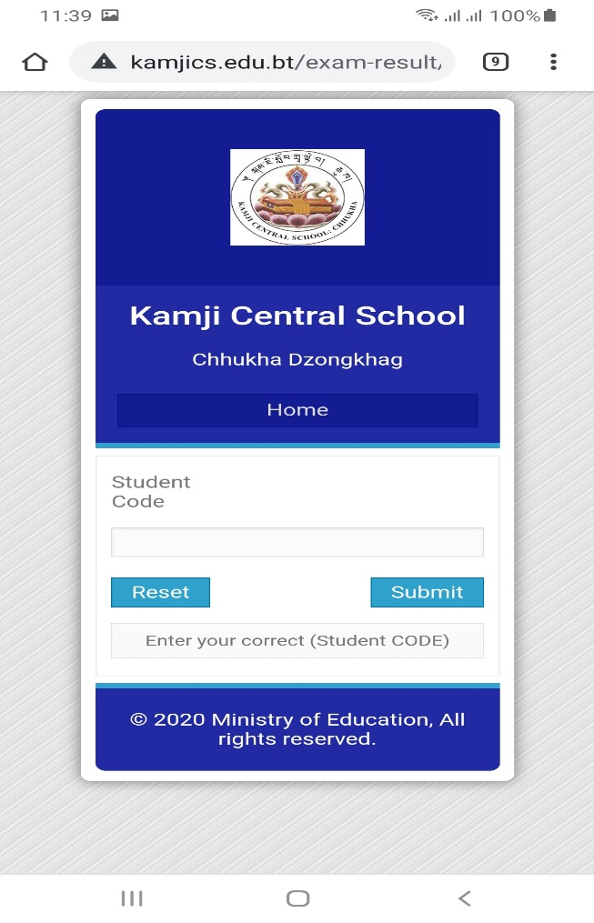

1. Your result page will display as follow:

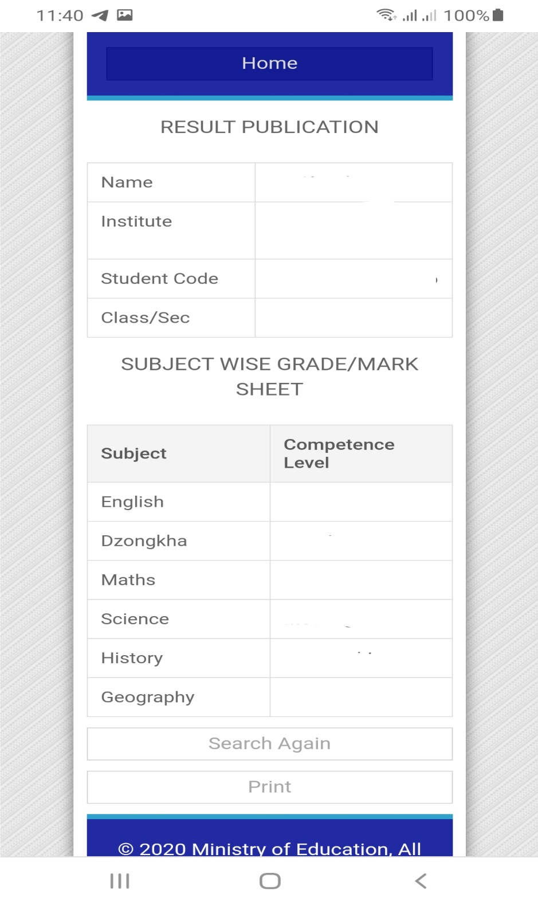

1. If you want to print your result, hit the Print button